Gene Livshin, Harish Visweswaraiya

CRISA CLUSTERing

CRISA Bath Soap Data IDS 572 Assignment 3 10/25/2015

Contents

Introduction – Excerpts from Assignment 2

Summary of Approach 2

Variable Selection 2

Cluster Development and Testing 4

K-Means Performance 5

Purchase Behavior Variable Set 5

Basis for Purchase Variable Set 14

Combination of Variables 20

Choosing the best Cluster 26

Summary of Cluster Modeling Techniques 26

Choosing the Best Technique 27

Best Technique - Purchase Behavior 27

Describing the Best Technique - Purchase Behavior 30

Best Technique - Basis-for-Purchase 31

Description of Best Segmentation Methods Using Decision Tree 32

# Introduction – Excerpts from Assignment

CRISA is a leading market research agency that specializes in tracking consumer purchase behavior in consumer goods (both durable and non-durable).  CRISA has traditionally segmented markets on the basis of purchaser demographics. They would like now to segment the market based on two key sets of variables more directly related to the purchase process and to brand loyalty:

1. Purchase behavior (volume, frequency, susceptibility to discounts, and brand loyalty)
2. Basis of purchase (price, selling proposition)

Doing so would allow CRISA to gain information about what demographic attributes are associated with different purchase behaviors and degrees of brand loyalty, and more effectively deploy promotion budgets.  The better and more effective market segmentation would enable CRISA’s clients to design more cost-effective promotions targeted at appropriate segments. Thus, multiple promotions could be launched, each targeted at different market segments at different times of a year. This would result in a more cost-effective allocation of the promotion budget to different market segments. It would also enable CRISA to design more effective customer reward systems and thereby increase brand loyalty.

## Summary of Approach

Our goal was to use the provided data to create clusters of household that would allow CRISA to target the two key sets of variables relating to purchase behavior and basis of purchase. At a high level we used the following steps to solve this problem:

1. Choose variables from the data set that would be used to create clusters for the two business questions. These choices would be based on domain knowledge and experimentation.
2. Test a variety of clustering techniques to create clusters representing the two sets of variables. The evaluation of the techniques would be focused on: cluster sizes, centroids, separation of clusters, density within clusters, and visualization of clusters on a graph.
3. Once choosing the best techniques for both sets of variables we will use the other demographic variables provided in the data to label and describe the clusters. This will be done using aggregate functions and a decision tree.
4. We will then use the labeled clusters to provide recommendations on how the clusters can be used in promotional and marketing campaigns.

# Variable Selection

Given the problem that is posed in the assignment, we decided to create two sets of variables that would represent the following:

1. Purchase behavior (volume, frequency, susceptibility to discounts, and brand loyalty.
2. Basis of purchase (price, selling proposition)

We used **range transformation** for normalizing all the below attributes. The min value used was 0 and the max value used was 1.

The following variables were used to describe **purchase behavior**:

* Avg. Price - Average price of the purchase
* Brand Runs - Number of instances of consecutive purchase of brands
* No. of Trans - Number of purchase transactions; Multiple brands purchased in a month are counted as separate transactions
* No. of Brands - Number of brands purchased
* maxBrCd - Max calculation of brand percentage columns (Codes (57, 144), 55, 272, 286, 24, 481, 352, 5).  This shows if any particular brand dominates purchase.
* Others 999 - Percent of volume purchased of all other brands (other than those in maxBrCD)
* Total Volume - Sum of volume
* Trans / Brand Runs - Avg. transactions per brand run
* Value - Sum of value

**Brand Loyalty Measurement**

Out of the variables chosen to describe purchase behavior, the following describes how the variables apply to brand loyalty.  The variable maxBrCd is used to indicate if a household has a main brand that it uses.  It doesn’t matter which brand but the field will be used to segment which household have a dominant brand vs households that have high Others999 which would indicate a mix of brands.  Brand Runs variable indicates how often the household goes back to purchase the same brand which is an indication of brand loyalty.  Trans / Brand Runs indicates whether the household purchases many items for that brand run.  Lastly, No. of Brands could indicate a household with a small number of brands could be brand loyal.

**How should the percentages of total purchases comprised by various brands be treated? Isn’t a customer who buys all brand A just as loyal as a customer who buys all brand B? What will be the effect on any distance measure of using the brand share variables as it is?**

Yes, a customer who buys all brand A is just as loyal as brand B. To treat the percentages of total purchases comprised by various brands we created a variable called **‘*maxBrCd’*** which is the maximum value of the brand code that is purchased. This can prove to be a vital factor in identifying whether a customer is brand loyal or not.

The following variables were used to describe **basis of purchase**:

* Percent of volume purchased not on promotion (Pur Vol No Promo-%)
* Percent of volume purchased on promo code 6 (Pur Vol Promo 6%)
* Percent of volume purchased on promo code other than 6 (Pur Vol Other Promo %)
* Price category 1 (Pr Cat 1)
* Price category 2 (Pr Cat 2)
* Price category 3 (Pr Cat 3)
* Price category 4 (Pr Cat 4)
* Proposition category 5 (PropCat5)
* Proposition category 6 (PropCat6)
* Proposition category 7 (PropCat7)
* Proposition category 8 (PropCat8)
* Proposition category 9,10,11,12,13,15 (PropCat9_10_11_12_13_15)
* By Data Exploration, we found that Proposition Categories of above types were less when compared to others. So, we included them with others and combined them into a single group
* Proposition category 14 (PropCat14)

The following variables were used to try a **combination of purchase behavior and basis for purchase**.  We believed that we should limit the number of variables in this case so that it would be easier to describe the clusters.

We excluded few variables because they had very less impact on cluster segmentation or were redundant. They are:

Percent of volume purchased on other promotions, Proposition category that were included in others, Proposition category 14 (redundant as Price category 3 also denotes the same data), Others 999, No. of Transactions, Total Volume (Redundant because of using ratios) and Value.

We ended up with final set of variables listed below:

* Percent of volume purchased not on promotion (Pur Vol No Promo-%)
* Percent of volume purchased on promo code 6 (Pur Vol Promo 6%)
* Price category 1 (Pr Cat 1)
* Price category 2 (Pr Cat 2)
* Price category 3 (Pr Cat 3)
* Price category 4 (Pr Cat 4)
* Proposition category 5 (PropCat5)
* Proposition category 6 (PropCat6)
* Proposition category 7 (PropCat7)
* Proposition category 8 (PropCat8)
* Avg. Price - Average price of the purchase
* Brand Runs - Number of instances of consecutive purchase of brands
* No. of Brands - Number of brands purchased
* maxBrCd - Max calculation of brand percentage columns (Codes (57, 144), 55, 272, 286, 24, 481, 352, 5).  This shows if any particular brand dominates purchase.
* Trans / Brand Runs - Avg. transactions per brand run

# Cluster Development and Testing

The following describes the clustering techniques used in RapidMiner and methods we used to evaluate the performance between the models.

Techniques used:

1. K-Means
2. K-Medoids
3. Kernel K-Means
4. Agglomerative Clustering
5. DBSCAN

Evaluation Criteria:

1. Cluster Sizes - The clusters should not be very lopsided with many items in some clusters and a small number in other clusters.
2. Centroids - The clusters should be well separated with average values of the input variables.  The clusters should have different properties and can be well described.
3. Separation of Clusters - For centroid based clustering techniques (K-Means and K-Medoids) the distance between the clusters can be measured.  The clusters should be well separated.
4. Cluster Density - The clusters should be densely populated to indicate members are all related and well categorized.
5. Visualization - We used SVDReduction operator to reduce the input variables into three dimensions after clustering.  This allows the use of a three dimensional plot to visually inspect the separation and density of the clusters.

## K-Means Performance

For all variable combinations we started with K-Means clustering method. We used K values of 2 through 5 which specifies the number of clusters to be generated.  The Cluster Distance Performance operator was used to measure the within cluster distances and the Data to Similarity operator was used to measure distances between clusters.  For both clustering models we used MixedMeasures measure type and MixedEuclideanDistance because we had a mix of nominal and numerical variables.

Below is a summary of findings for K-Means testing to demonstrate differences between the uses of parameters. For all other models a summary of performance can be found in the appendix.

### Purchase Behavior Variable Set

**For k = 2 (2 Cluster Segmentation)**

Cluster Counts

https://lh6.googleusercontent.com/_Jef1TQ7Dj2CYulfPiS43HQwGc974v3C3Nobrs3nEKJ8A2CVzeIhcNx-nsRk6xbtoRdv6WX-8nV-yVqlrCh0RCkuNoumiRjezsOJIaDvVGXw0AE-5MUBjwer3qyrtC7DZWcsw7uPb5y9I60

Within Cluster Density

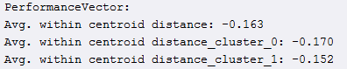

Distance between Clusters

https://lh6.googleusercontent.com/xQr9gPWAZxy30-45h3w2tHvR92GB0PlNEqgiwZfmgEhDZle2Wo5Hnkq4Bg6mOvx99tQ-fZjbR6O8Ukz4r3zQ2cIFiYr7AZNQ4C_K43Sml3Apih8JSNECoj80Uce5xRLXbEiZHFxZdBm4J1s

Centroid table

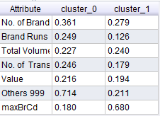

Avg Variable Values Plot

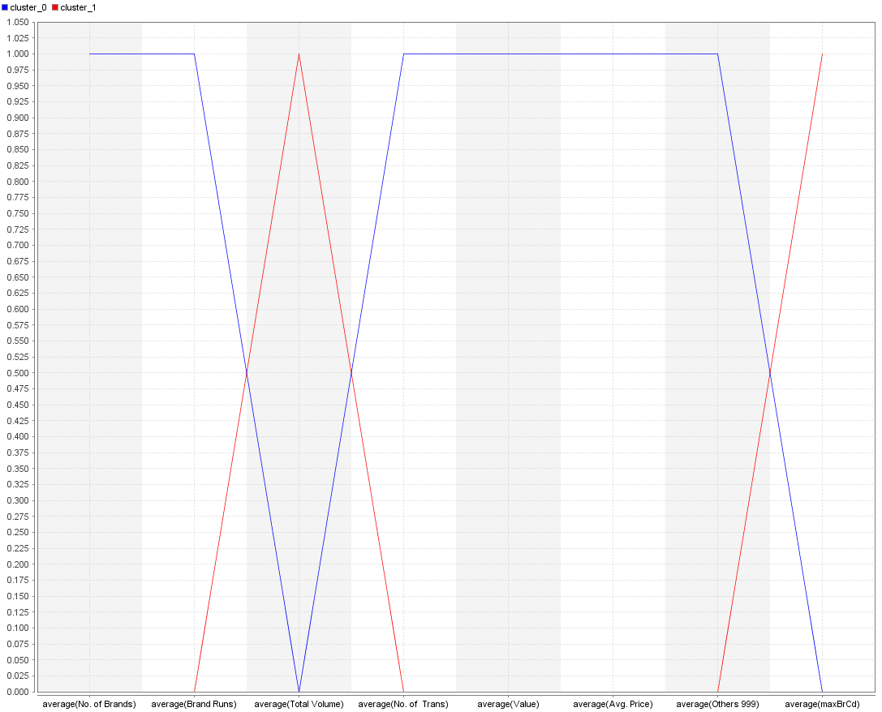

SVD Graph

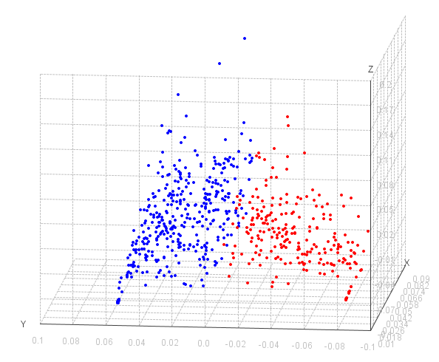

**Cluster Interpretations:**

* Clusters are not evenly distributed, cluster 0 much larger than cluster 1
* Cluster 1 is more dense than cluster 0
* Clusters are well defined for centroid values
* Cluster 1 could be more brand loyal because high maxBrCd and low Others999
* Cluster 1 also buys larger volume items with less number of transactions

**For k = 3 (3 Cluster Segmentation):**

Cluster Counts

https://lh5.googleusercontent.com/qH9WqJG8eP8rVrYAyBYXsZdxoSWFEoEmg7EL_c_jqHPtmpfvvPNvSlJA1BjJi0aFvYbVHiyL7qAdum3JrtEeV1aeW0kk9Qyazx2jujRbAuJH8aBz3yT8F3Q2jG5MF9eTfJkS31hmuxGf69Y

Within Cluster Density

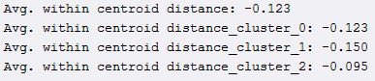

Distance between Clusters

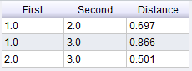

Centroid table

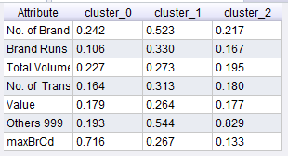

Avg Variable Values Plot

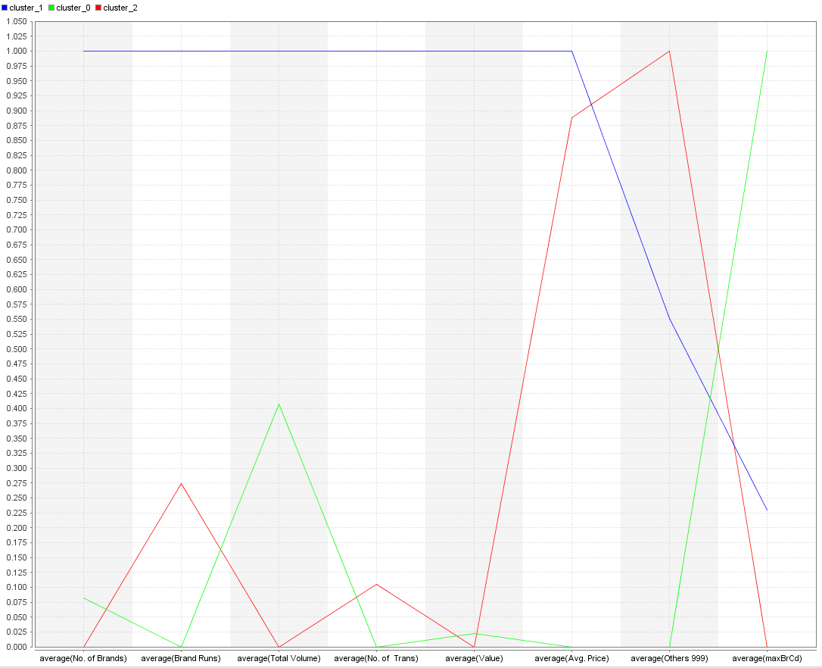

SVD Graph

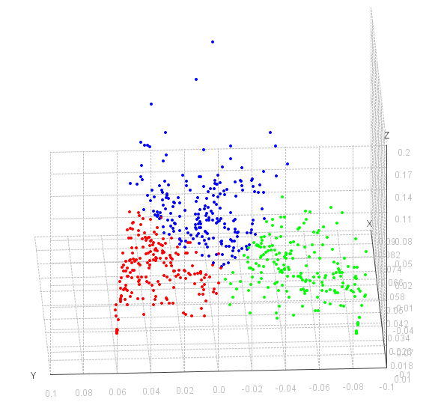

**Cluster Interpretations:**

* Clusters are evenly distributed with a even amount of households in each cluster
* Cluster 2 is the most dense while cluster 1 is the least dense
* Clusters 0 and 2 are too similar for centroid values especially for number of brands, number of transactions, and value
* Cluster 0 is probably the most brand loyal but has low transactions

**For k = 4 (4 Cluster Segmentation):**

Cluster Counts

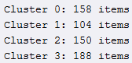

Within Cluster Density

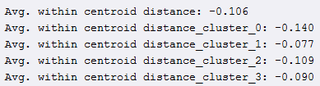

Distance Between Clusters

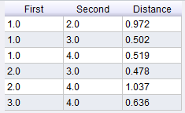

Centroid table

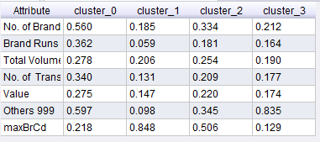

Avg Variable Values Plot

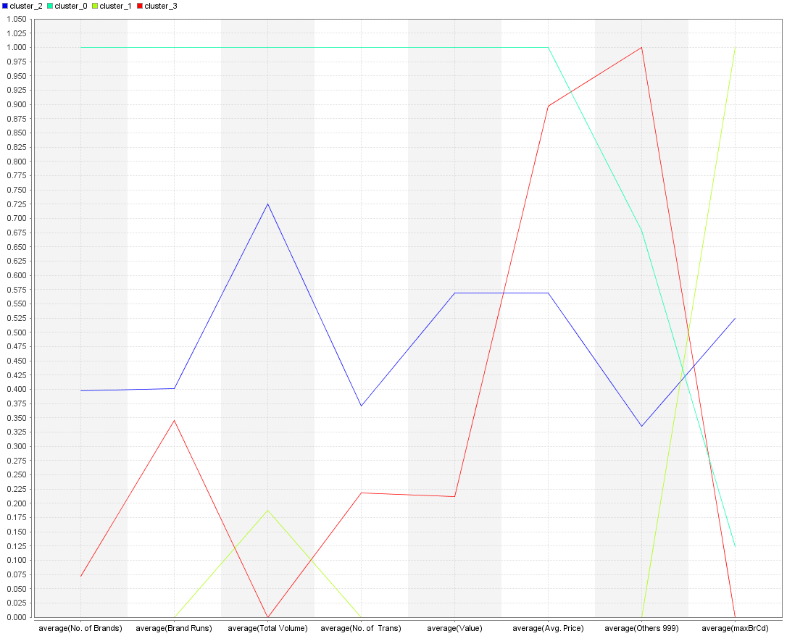

SVD Graph

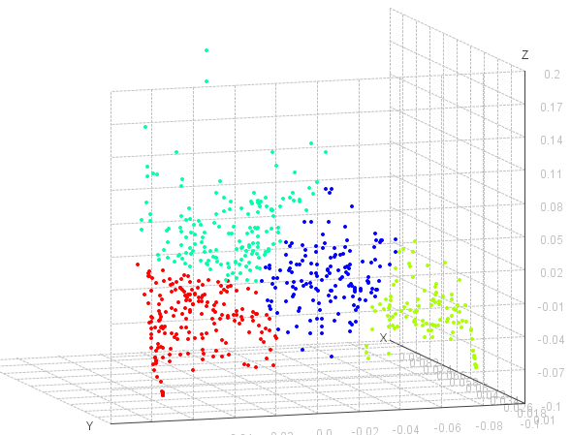

**Cluster Interpretations:**

* Clusters are relatively evenly distributed in size although cluster 1 is small
* All clusters show good density performance
* Clusters are well separated on the average variable graph.
* Cluster 2 is around middle values for all variables
* Cluster 1 shows as brand loyal

**For k = 5(5 Cluster Segmentation):**

Cluster Counts

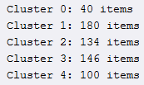

Within Cluster Density

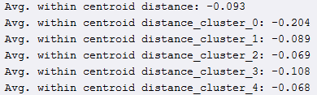

Distance Between Clusters

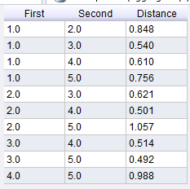

Centroid table

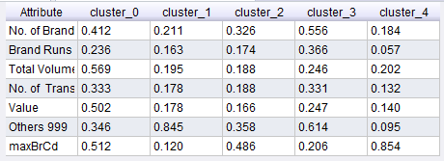

Avg Variable Values Plot

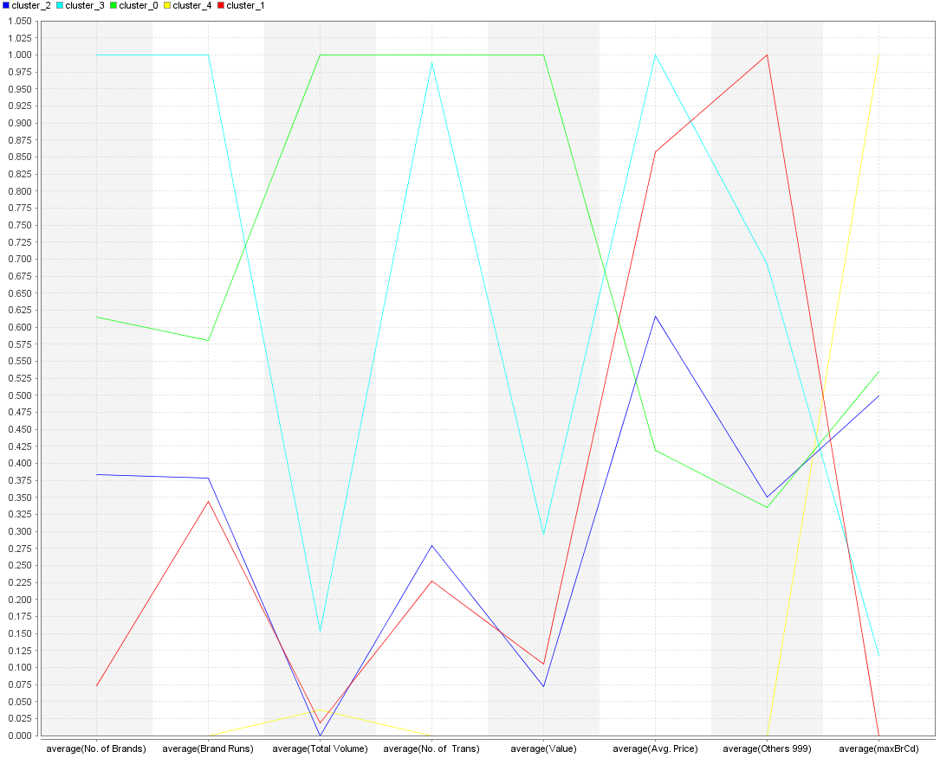

SVD Graph

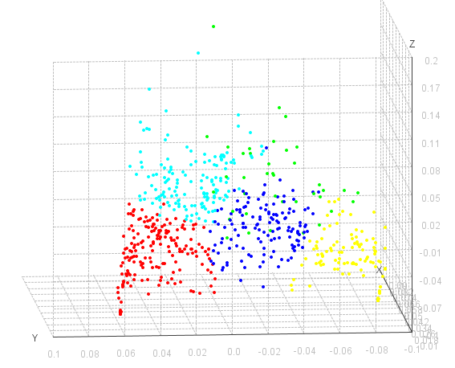

**Cluster Interpretations:**

* Cluster sizes are not evenly distributed
* Cluster 0 has poor density
* Clusters are not well separated on the graph.  Cluster 1 and 2 in particular follow to closely on variable values.

### Basis for Purchase Variable Set

**For k = 2 (2 Cluster Segmentation):**

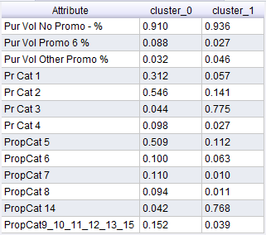

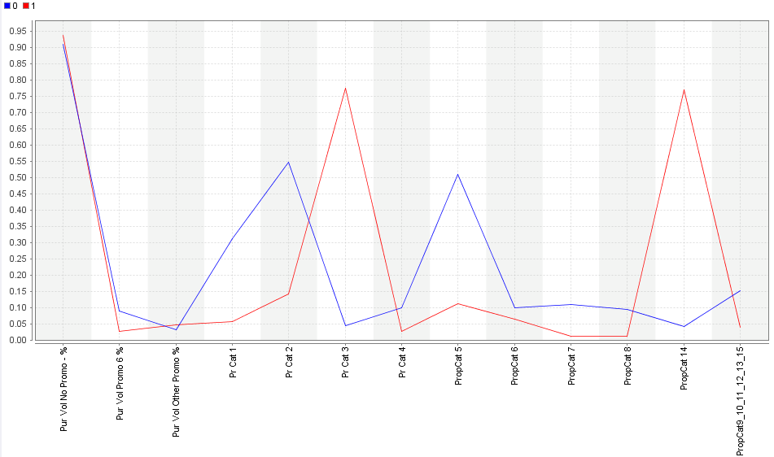

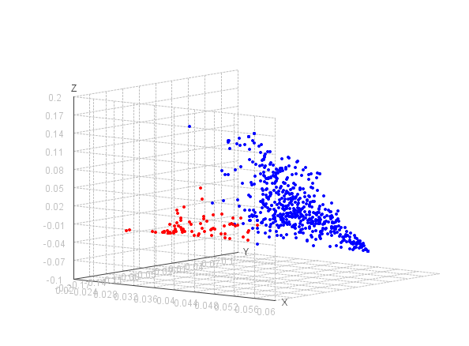

**Cluster Interpretations:**

* Cluster 0 households are way more than households in cluster 1.
* Purchase patterns show cluster 0 prefer ‘Popular Soap’ whereas cluster 1 prefer ‘Economy/Carbolic’ soap.
* It can inferred that cluster 0 prefer ‘Beauty Soap’
* Households in cluster 0 have comparatively high value for ‘Pur Vol Promo’ which signifies their dependence on discounts for purchase.

**For k = 3 (3 Cluster Segmentation):**

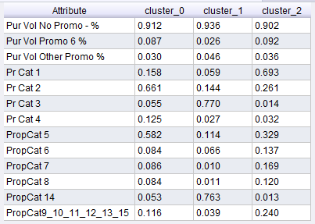

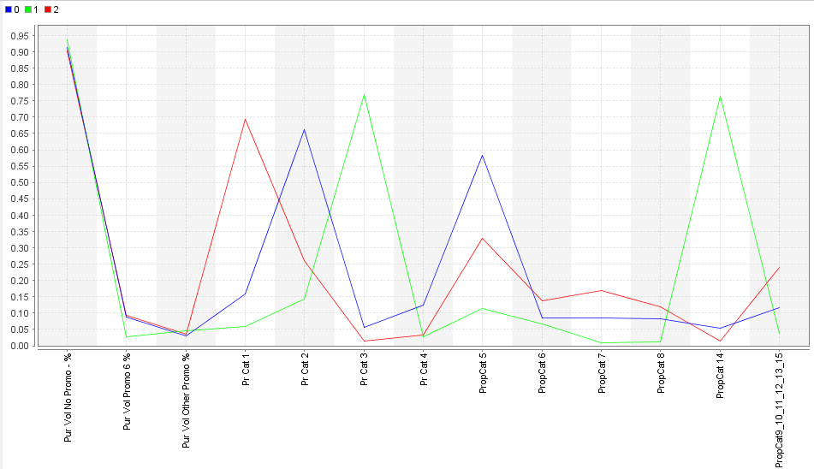

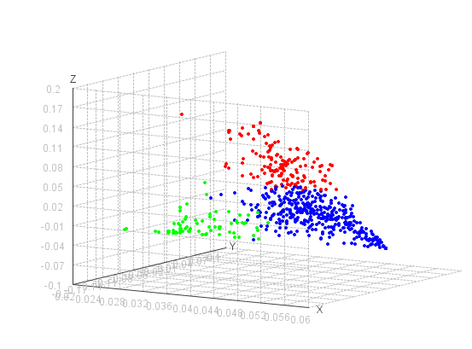

**Cluster Interpretations:**

* Cluster 0 households are more than households in clusters 1 & 2.
* Purchase patterns show cluster 0 prefer ‘Popular Soap’ whereas cluster 1 prefer ‘Economy/Carbolic’ soap and cluster 2 prefer ‘Premium Soap’

**For k = 4 (4 Cluster Segmentation):**

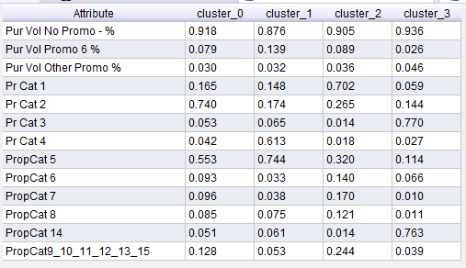

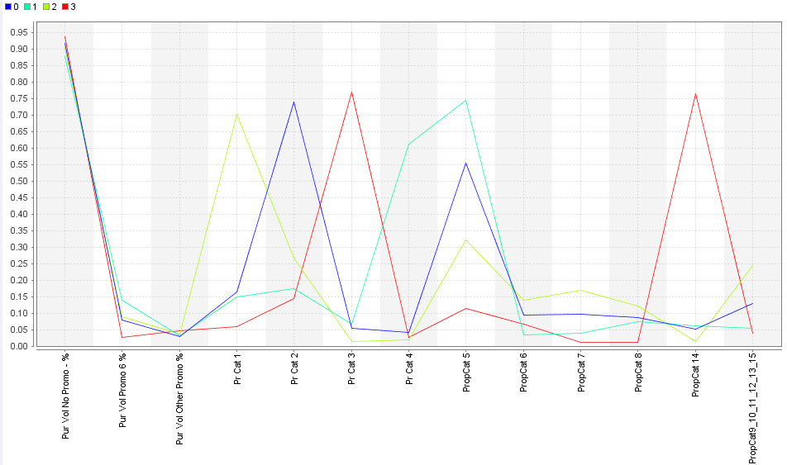

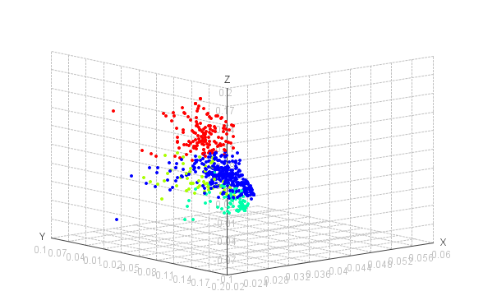

**Cluster Interpretations:**

* Cluster 0 households are more than other cluster households.
* Purchase patterns show cluster 0 prefer ‘Popular Soap’, cluster 1 prefer ‘Sub-popular’, cluster 2 prefer ‘Premium Soap’ and cluster 3 prefer ‘Economy/Carbolic’ soap
* We notice that ‘Beauty Soap’ is more preferred by households in clusters 0 & 1, who we already know that they prefer soaps that are popular

**For k = 5 (5 Cluster Segmentation):**

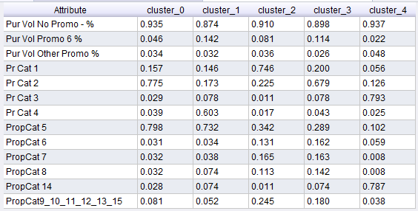

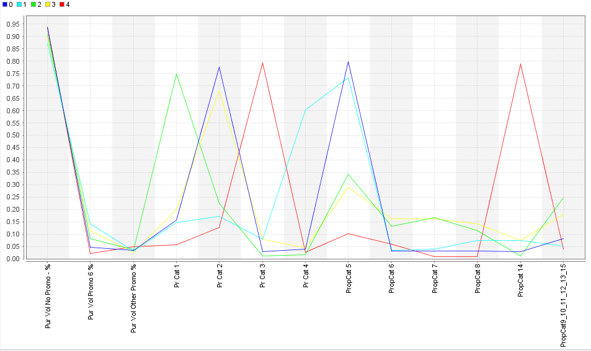

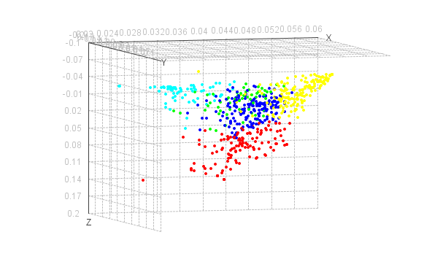

**Cluster Interpretations:**

* Purchase patterns show clusters 0 & 3 prefer ‘Popular Soap’, cluster 1 prefer ‘Sub-popular’, cluster 2 prefer ‘Premium Soap’ and cluster 4 prefer ‘Economy/Carbolic’ soap
* We notice that ‘Beauty Soap’ is more preferred by households in clusters 0 & 1, who we already know that they prefer soaps that are popular
* Households in clusters 2 & 3 prefer ‘Health & Herbal Soaps’

### Combination of Variables

**For k = 2 (2 Cluster Segmentation):**

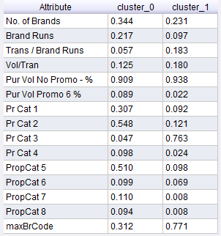

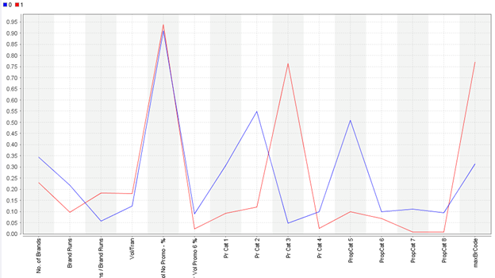

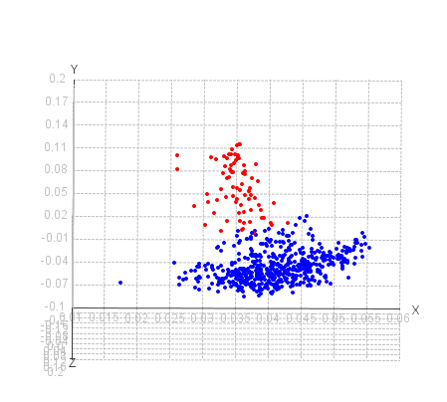

**Cluster Interpretations:**

* Cluster 0 households are way more than households in cluster 1.
* Purchase patterns show cluster 0 prefer ‘Popular Soap’ whereas cluster 1 prefer ‘Economy/Carbolic’ soap.
* It can inferred that cluster 0 prefer ‘Beauty Soap’
* Also, we notice that households that use ‘Economy Soap’ – cluster 1 are more brand loyal as they also use less no of brands

**For k = 3 (3 Cluster Segmentation):**

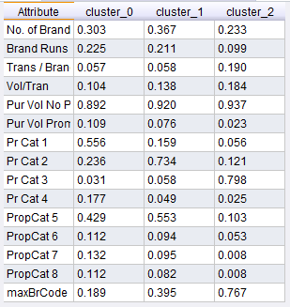

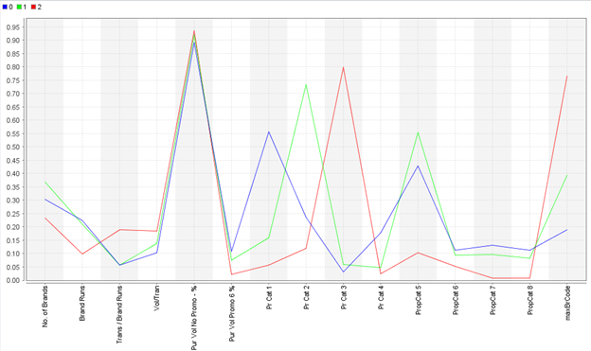

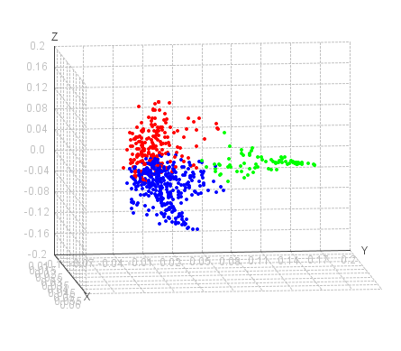

**Cluster Interpretations:**

* Cluster 1 households are more than households in clusters 0 & 2.
* Purchase patterns show cluster 0 prefer ‘Premium Soap’ whereas cluster 1 prefer ‘Popular’ soap and cluster 2 prefer ‘Economy Soap’
* Cluster 2 households are more brand loyal when compared to other households

**For k = 4 (4 Cluster Segmentation):**

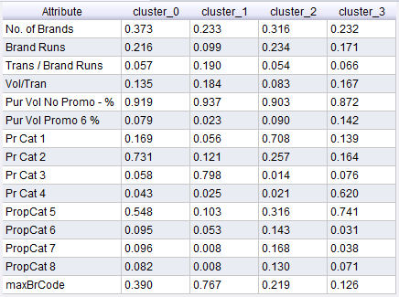

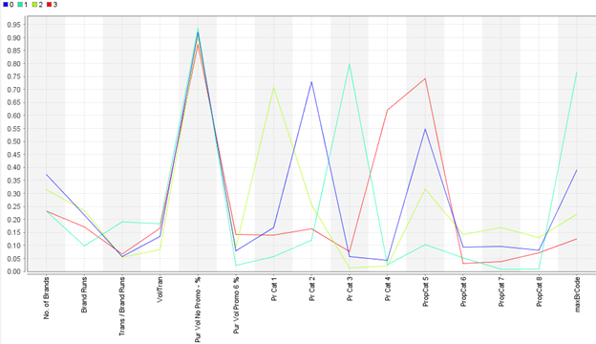

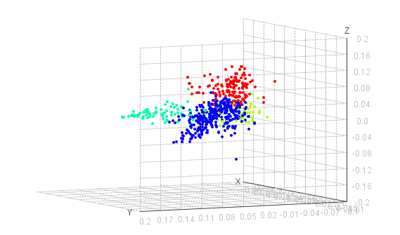

**Cluster Interpretations:**

* Purchase patterns show cluster 0 prefer ‘Popular Soap’, cluster 3 prefer ‘Sub-popular’, cluster 2 prefer ‘Premium Soap’ and cluster 1 prefer ‘Economy/Carbolic’ soap
* We notice that ‘Beauty Soap’ is more preferred by households in clusters 0 & 1, who we already know that they prefer soaps that are popular
* Households that prefer ‘Economy soap’ are more brand loyal

**For k = 5 (5 Cluster Segmentation):**

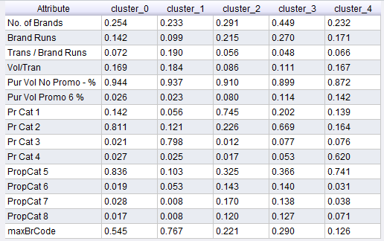

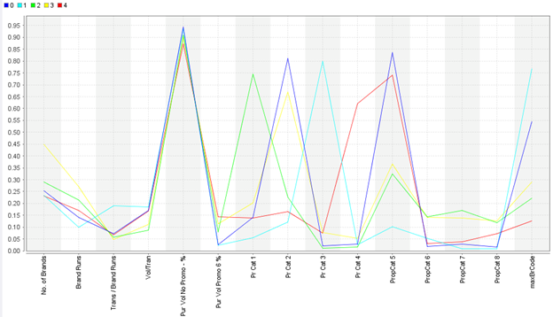

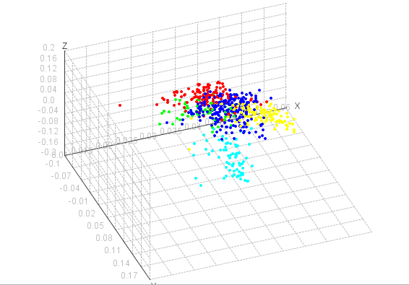

**Cluster Interpretations:**

* Purchase patterns show clusters 0 & 3 prefer ‘Popular Soap’, cluster 4 prefer ‘Sub-popular’, cluster 2 prefer ‘Premium Soap’ and cluster 1 prefer ‘Economy/Carbolic’ soap
* We notice that ‘Beauty Soap’ is more preferred by households in clusters 0 & 4, who we already know that they prefer soaps that are popular
* Households in clusters 2 & 3 prefer ‘Health & Herbal Soaps’
* Again, we notice that households that prefer ‘Economy Soap’ are more brand loyal

### Choosing the best Cluster

Since this is a marketing effort consisting of 600 household data, a 3-4 cluster solution can be ideal because any marketing firm would not want to have large number of marketing approaches to target more than 4 set of households. Similarly, having just 2 segments of people to target a marketing promotion will incur more cost and might not prove effective with just 2 clusters

## Summary of Cluster Modeling Techniques

As you have seen the detailed output from the K-Means testing, the following will be a summary of

the rest of the modeling techniques and settings we used while testing.  A detailed summary of output can be found in the attached performance spreadsheet.

**K-Medoids**

Setting for this technique are the same as K-Means.  A value of K is chosen (we tried 2-5) and a distance measuring type.  Since we had a mix of Nominal and Numerical values we used MixedEuclideanDistance as before.  Performance for K-Medoids was similar to K-Means.

**Kernel K-Means**

Kernel K-Means is similar to K-Means and K-Medoids except it uses kernel functions to estimate the distances between points.  Like K-Means, we adjusted the value of K to indicate the number of clusters to form.  We found better performance using the Radial Kernel type and varied the gamma value.  For purchase behavior we found better performance with higher gamma of 2.0 vs 0.5.

**Agglomerative Clustering (Hierarchical)**

For hierarchical clustering we transformed the input values from nominal to numerical.  We tested different modes for measuring distance between clusters (Single Link, Average Link, Complete Link).  We found that Complete Link performed better in most situations.  We also varied the measurement type and for purchase behavior we found that JaccardSimilarity performed well.  We tried different flattening points to create the clusters as well.  For purchase behavior we found that 4 clusters performed the best.

**DBSCAN**

For DBSCAN we also transformed the input values from nominal to numerical.  The two main settings to be changed for this model are Epsilon and Min Points.  We tried many combinations and found that the model is very sensitive to changes.  For purchase behavior for example, the best values we found were Epsilon = .21 and Min Points = 31, this created 3 relatively even clusters.  However, changing the Min Points to 30 created just 2 clusters with poor performance.

# Choosing the Best Technique

Given the problem that was given for CRISA, we decided to choose two models to solve the two problems.  One model would describe segmentation of purchase behaviour and the other one would describe the basis for purchase.  This meant that we did not need to use the combined variable set.  We think this is the best option because it will allow CRISA to target marketing efforts depending on which type of buyers they are trying to address.

## Best Technique - Purchase Behavior

Given the results found in the attached performance spreadsheet, there are several techniques and moves that we identified as well performing.  We narrowed it down to 2 models for purchase behaviour that needed to be decide between:

* Agglomerative Clustering (Hierarchical) - Mode = Complete Link, Measure = DynamicTimeWarping, Flatten to 3 clusters
* K-Means Kernel - K = 4, Radial Kernel, gamma = 2

Both techniques had good cluster count distribution as follows:

Agglomerative:

Cluster 0: 183 items  
Cluster 1: 216 items  
Cluster 2: 201 items

K-Means Kernel

Cluster 0: 159 items  
Cluster 1: 137 items  
Cluster 2: 135 items  
Cluster 3: 169 items

Both techniques also had good performance for within cluster distance:

Agglomerative:

Avg. within cluster distance: -124.987  
Avg. within cluster distance for cluster 0: -104.367  
Avg. within cluster distance for cluster 1: -130.104  
Avg. within cluster distance for cluster 2: -138.262

K-Means Kernel

Avg. within cluster distance: -66.418  
Avg. within cluster distance for cluster 0: -78.502  
Avg. within cluster distance for cluster 1: -66.339  
Avg. within cluster distance for cluster 2: -51.651  
Avg. within cluster distance for cluster 3: -66.907

These facts made it difficult to pick between the techniques.  However, a comparison of the average values of variables graphs shows that the agglomerative technique is a superior clustering model in this case.  You can see from the graphs below that the description of the clusters is much better separated for the Agglomerative model.  The K-Means Kernel graph has too many similar points for the variables between the clusters.

Agglomerative:

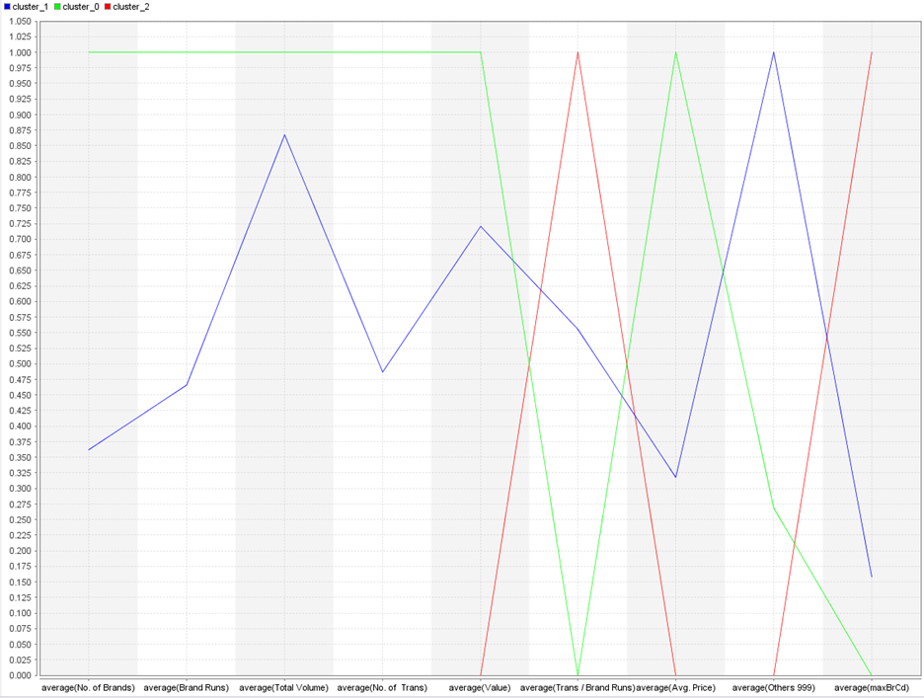

K-Means Kernel:

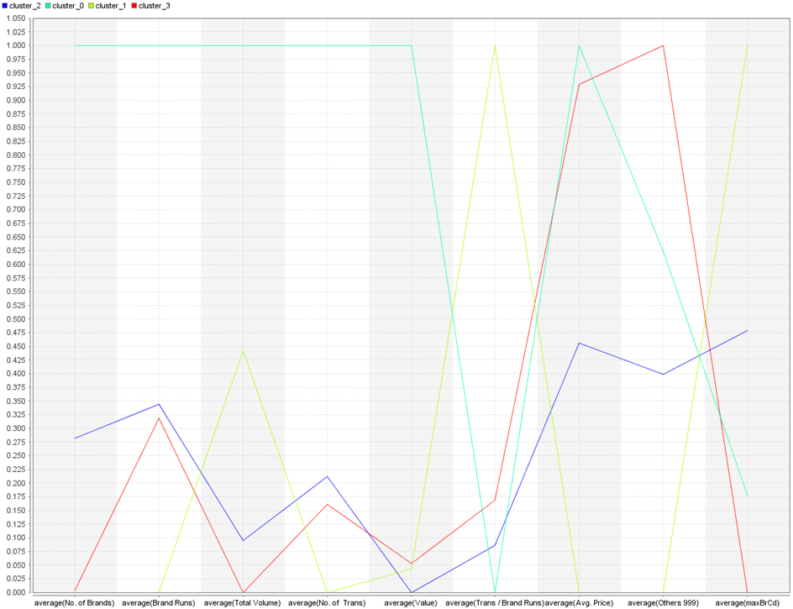

## Describing the Best Technique - Purchase Behavior

Now that we have chosen the Agglomerative technique as the best model for purchase behavior, we should do an analysis of how the model is described.  As seen from the graph above the clusters have the following characteristics:

Cluster 0

* High values for numbers of brands, brand runs, total volume, # of transactions, value, and price
* Low values for trans per brand run, Others 999, and maxBrCd
* The fact that the cluster has a high number of brands and low amount of dominance for a brand indicates weak brand loyalty.  Many brand runs but not a high amount of transaction per brand run also indicates that the household is switching brands frequently.
* However, these household are high volume shoppers indicated by the high # of transactions

Cluster 1

* High values in Others999 indicating that they may be purchasing a large amount of one of the brands not summarized in the data
* Medium amount of most variables indicating steady shopping

Cluster 2

* High values for maxBrCd transactions per brand run as well as low values for brand runs and  # of brands.  This indicates high brand loyalty as they have high values for brand code purchases and they purchase many transactions per brand run.  They also have a low total number of brands and less different brand runs which also indicates brand loyalty.
* Low values for price, value, # of transactions and volume.  This indicate that although these households are brand loyal, they do not have a high purchase rate.  Low number of transactions is evidence of this.  They also prefer lower price items and smaller volume.

## Best Technique - Basis-for-Purchase

While choosing the best technique based on basis-for-purchase, we should note that while using k-means, we found that best segmentation was obtained for k=4, where each cluster was able to uniquely identify itself under a respective price category(premium/popular/economy/sub-popular soaps). Hence, we nominate the k-Means as the candidate for best technique and compare it with other techniques. So, we chose k=4 as our requirement to see whether we are able to classify the clusters using other techniques and that they outweigh the advantages of using a k-Means model.

**K-Medoids (k=4)**

**Centroid plot**

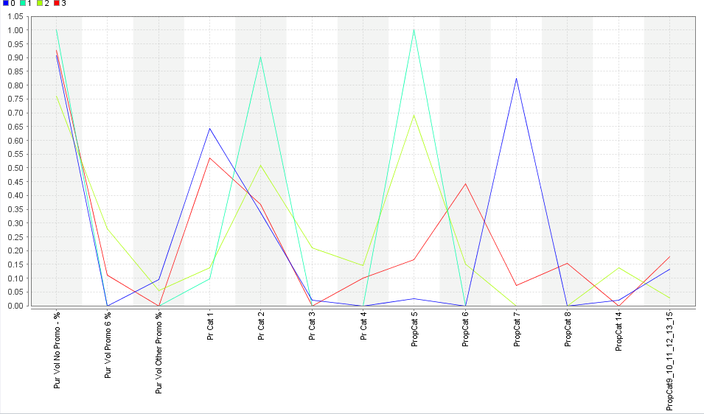

**Cluster interpretation:**

As we see in the above plot for k-Medoids, for Pr Cat 1 / 2 / 3 / 4, we see overlap of clusters. For example, clusters 0 & 3 have peaks for Pr Cat 1 (premium), whereas popular soaps correspond to clusters 1 & 2. So, we do not have definite peaks for each price category. Hence, k-Medoids is not a good candidate for best technique when compared to k-Means.

**k-Means kernel (k=4):**

**Aggregate values**

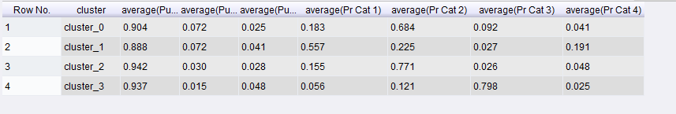

We calculated the aggregate values of each price category for respective clusters under k-Means kernel technique. Though, we noticed Cluster 1 was able to identify itself under Pr Cat 1 & Cluster 3 under Pr Cat 3, there were no clear winners for Pr Cat 2 & Pr Cat 4. Hence, kernel k-Means is not a good candidate as against k-Means technique

**DBSCAN & Agglomerative (k=4):**

We used DBSCAN and Agglomerative (Hierarchical) clustering techniques to form clusters based on basis-for-purchase set of variables. We noticed that it was not feasible to form 4 clusters that could interpret the data as we wanted using these techniques. Please refer to the appendix section Excel ‘Basis of purchase’ tab. In case of Density based Clustering(DBSCAN), though we were able to form 4 clusters, cluster size was highly skewed that one of the cluster included about 80% of data points. Similarly, we noticed that forming 4 clusters using Agglomerative technique is not feasible and that efficient clusters for the variables chosen for 2-3 clusters.

Thus, we identified **k-Means as the best segmentation technique for ‘Basis-of-purchase’.**

# Description of Best Segmentation Methods Using Decision Tree

Now that we selected our best clusters and defined them using the variable used to build the clusters, we want to use the rest of the data provided to describe the clusters.  Several others fields are provided that describe the demographics of the households.  We set the cluster variable created to the a label type attribute and used a decision tree to analyze the results.  It was difficult to obtain tree that were easy to describe the clusters however.  When the tree had good performance, the tree was too big to effectively use in analysis.

**Purchase Behavior**

A sample of a tree that was generated is provided in the appendix for the agglomerative clustering method we selected for purchase behavior.  The following ae some observations on the clusters from the demographic data:

Cluster 0

Cluster 1

Cluster 2

**Appendix**

**Agglomerative Decision Tree Output Snapshot (Purchase Behavior)**

